Anon Scans
Process to anonymise SS Scans by reducing polygon count on the the face.
Use LM’s to set region to reduce polygon count
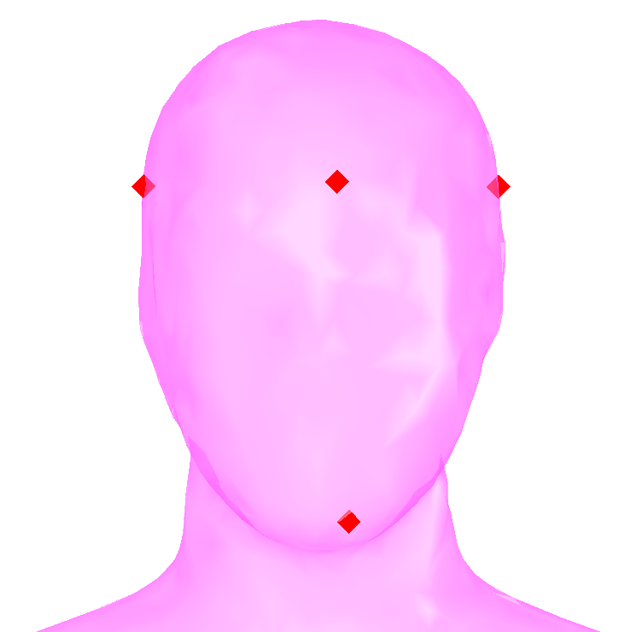 | 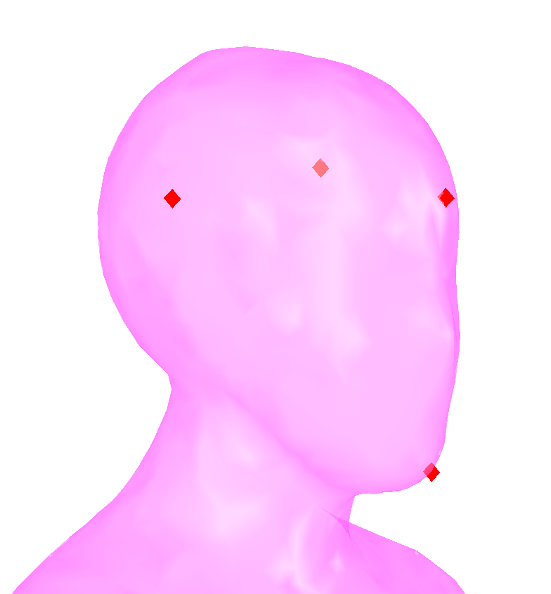
Chin to set bottom of region
Head Circum Front to set upper boundary
Head Circum Left & Right to set sides of bounding area

